BLTouch Installation Guide

Focused for the Archim2

v1.0   
2/9/2020

Contents

Purpose 1

Where to Buy a BLTouch Smart? 2

Electrical 3

Configurations 4

Using GPIO 5

Using Z-Min 6

Firmware 8

Marlin 9

Klipper 10

APPENDIX 12

Digikey Parts BOM 12

Wiring Diagram 13

Included in the root directory is a spreadsheet that outlines the parts used, the STL model of the printed heatsink mount (both [stock](http://download.lulzbot.com/TAZ/TAZ_Pro/v1.0.7/production_parts/printed_parts/heatsink_mount/) and modified as described in the Mechanical Section), and the [design drawing for the heatsink from Lulzbot](http://download.lulzbot.com/TAZ/TAZ_Pro/v1.0.7/production_parts/machined_parts/board_heatsink/Archim_board_heatsink.pdf). This information, as well as a wiring diagram are in the Appendix.

**Disclaimer:** You do this work at your own risk. Your warranty will likely be voided by doing this. It is up to the implementer if the advantages of doing this work outweigh the risks. Wiring, crimping, and soldering may be involved.

Purpose

The purpose of the guide is to assist users with the installation of the BLTouch Smart in their system. This document focuses on the Archim2 controller board which is a 32-bit, 84MHz board that is used in the Lulzbot TAZ Pro and my modified Lulzbot TAZ6. Provided are the steps that I took to complete my installation on the modified TAZ6.

**Why would you want to do this?** The BLTouch is a retractable probe that is very repeatable and can achieve very high accuracy probing on any bed surface. The current version at the time of this writing is v3.1 and is supported by Marlin and Klipper (as well as other firmware I am sure).

# Where to Buy a BLTouch Smart?

The BLTouch is made by [Antclabs](https://www.antclabs.com/) and can be purchased from Amazon. Please take care when ordering and get a **genuine BLTouch Smart v3.1** (or newer). There are many clones that may not perform as well or follow the same installation procedure. I am also a fan of supporting the original creators of this device.

The BLTouch Smart v3.1 supports a “Logic Voltage Free” feature, which will be important in the compatibility of the device with the various boards available.

# Electrical

This section covered the electrical considerations for the installation. The images below outline the connections that are referenced and the wiring that was done.

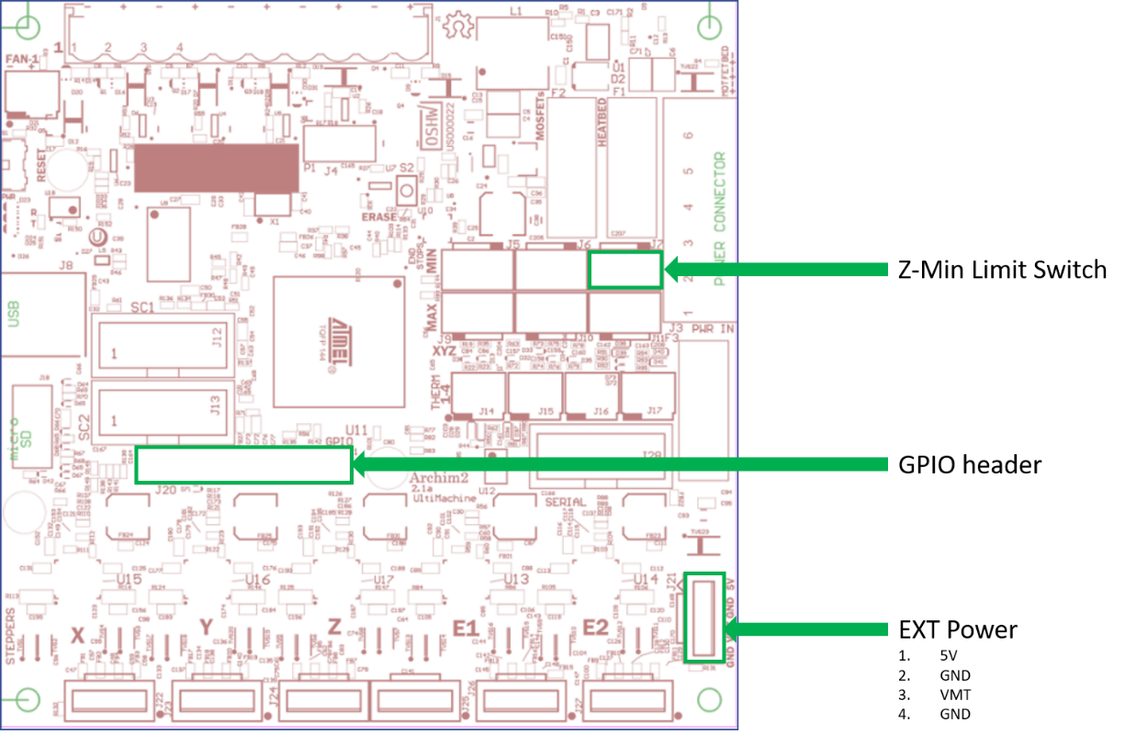

Archim2 v2.2b (current board revision being shipped). [Schematics](https://github.com/ultimachine/Archim/blob/c68ed12ccc4da3c50be3b65031d0f8b64b89efce/Project%20Outputs/Archim2_2.1a_Schematic.PDF) can be found on the [reprap wiki](https://reprap.org/wiki/Archim2).

## Configurations

There are two configurations that can be used with respect to how the probe is connected. You should choose which one is best based on the information [here](https://www.antclabs.com/wiring). Basically, you can connect the probe signal to the Z-Min switch, or to the GPIO header. I chose the GPIO header for my install so I didn’t have to worry about the additional capacitance on the Z-Min pin, but that was using the Klipper firmware.

**About the connections:**

* Red wire: 5V power source for the BLTouch.
  + This needs to be 5V even if you have a 3.3V system (like the Archim2). The v3.1 will pull ~300mA when controlling the pin, but this current draw only lasts about 0.1 seconds. The idle current draw is much lower at ~15mA. Make sure your 5V power supply can supply the peak current needed.
* Brown Wire: Ground.
  + Common to Black wire.
* Black Wire: Ground.
  + Common to Brown wire.
* Orange: Control signal.
  + This input is 5V and 3.3V capable, meaning that both logic levels can drive it. This feature is called “Logic Voltage Free” and supported on the BLTouch Smart 3.1 (and 3.0?) which makes this version plug-n-play on a 3.3V or 5V board without any need to level shift.
* White Wire: Probe signal.
  + This output is also “Logic Voltage Free” by default using an open collector to pull a signal to ground (instead of supplying a voltage). It can also be configured to output a voltage signal to indicate a trigger, but should only be reconfigured for this in special cases. The “Logic Voltage Free” feature makes this version plug-n-play on a 3.3V or 5V board without any need to level shift.

[More information on the BLTouch 3.1 can be found on the Users Manual including information about using 5V mode if needed.](https://5020dafe-17d8-4c4c-bf3b-914a8fdd5140.filesusr.com/ugd/f5a1c8_d40d077cf5c24918bd25b6524f649f11.pdf)

[Other BLTouch Users manuals can be found here.](https://www.antclabs.com/manual)

### Using GPIO

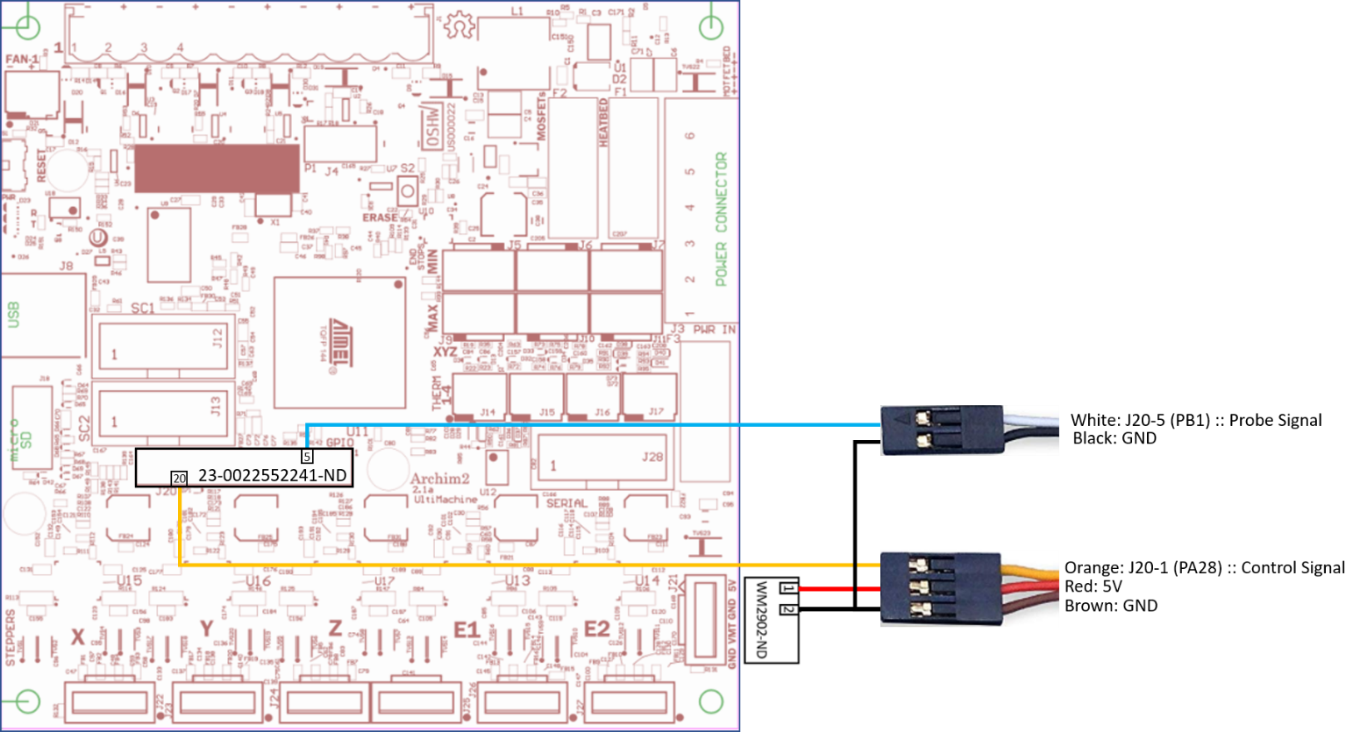

See Appendix or included spreadsheet for Digikey BOM and enlarged image.

**Power:**  
For the GPIO configuration, both the Control and Probe signals go to the GPIO header (Part number for the connector housing shown). The BLTouch shares a common ground with the probe connector and control connector, so they can be connected together. Presumably, there are two grounds so that the wiring to existing connectors on boards is easier. The 5V source is driven from the EXT Power connector on the Archim2 from Pin 1 and Ground is available on Pin 2 (the part number for the mating connector for J21 is shown).

**Signals:**  
The control signal for the BLTouch (orange wire) is directly connected to the GPIO header (J20) on Pin 20 of the Archim2 board. This connects to the microcontroller pin **PB12** and needs to be defined in the firmware as an output that follows the control signal specification defined in the User Manual. Common firmware bases (like Marlin and Klipper) have support for this device already and enabling it in the firmware configuration will activate the required code to drive it properly. See the last page of the [Users Manual for Marlin](https://5020dafe-17d8-4c4c-bf3b-914a8fdd5140.filesusr.com/ugd/f5a1c8_d40d077cf5c24918bd25b6524f649f11.pdf) and the [Extra Config options for Klipper](https://github.com/KevinOConnor/klipper/blob/master/config/example-extras.cfg).

The probe signal wire for the BLTouch (white wire) is also directly connected to the GPIO header (J20) on pin 5 of the Archim2 board. This connects to the microcontroller pin **PB1** and needs to be defined in the firmware as an input with internal pullup resistor enabled (if external pull-up is not present).

### Using Z-Min

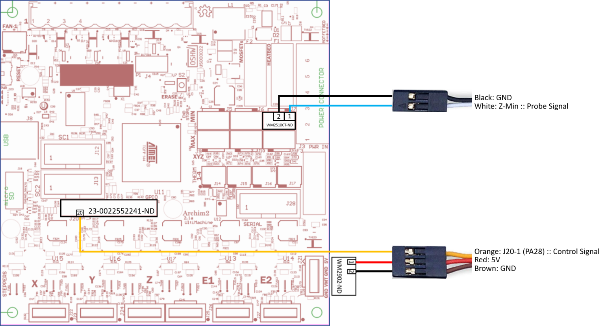

See Appendix or included spreadsheet for Digikey BOM and enlarged image.

**Power:**  
For the GPIO configuration, both the Control and Probe signals go to the GPIO header (Part number for the connector housing shown). The BLTouch shares a common ground with the probe connector and control connector, so they can be connected together. Presumably, there are two grounds so that the wiring to existing connectors on boards is easier. The 5V source is driven from the EXT Power connector on the Archim2 from Pin 1 and Ground is available on Pin 2 (the part number for the mating connector for J21 is shown).

**Signals:**  
The control signal for the BLTouch (orange wire) is directly connected to the GPIO header (J20) on Pin 20 of the Archim2 board. This connects to the microcontroller pin **PB12** and needs to be defined in the firmware as an output that follows the control signal specification defined in the User Manual. Common firmware bases (like Marlin and Klipper) have support for this device already and enabling it in the firmware configuration will activate the required code to drive it properly. See the last page of the [Users Manual for Marlin](https://5020dafe-17d8-4c4c-bf3b-914a8fdd5140.filesusr.com/ugd/f5a1c8_d40d077cf5c24918bd25b6524f649f11.pdf) and the [Extra Config options for Klipper](https://github.com/KevinOConnor/klipper/blob/master/config/example-extras.cfg).

The probe signal wire for the BLTouch (white wire) is directly connected to the Z-Min connector on the Archim2 board. Pin 1 on J7 is the Z-Min signal, which goes to **PA7**, and Pin 2 is ground. This signal is pulled-up to 3.3V using an external 100K resistor.

# Mechanical

This section will attempt to cover the mechanical considerations in mounting the BLTouch to your toolhead. My machine is a Lulzbot TAZ6 with Dual v3 extruder. I designed a mount that uses existing mounting holes and the STL is available to others who have the same toolhead. A custom solution may need to be developed for your toolhead. STL’s can be found online that may work for you. Otherwise, some design time may be needed to craft your own mount.

My Dual v3 BLTouch Mount:

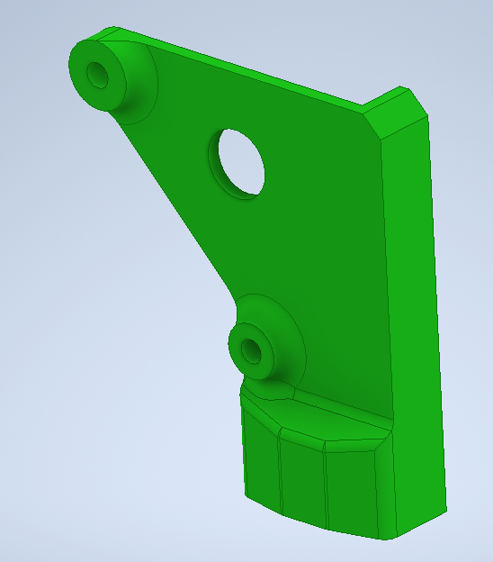 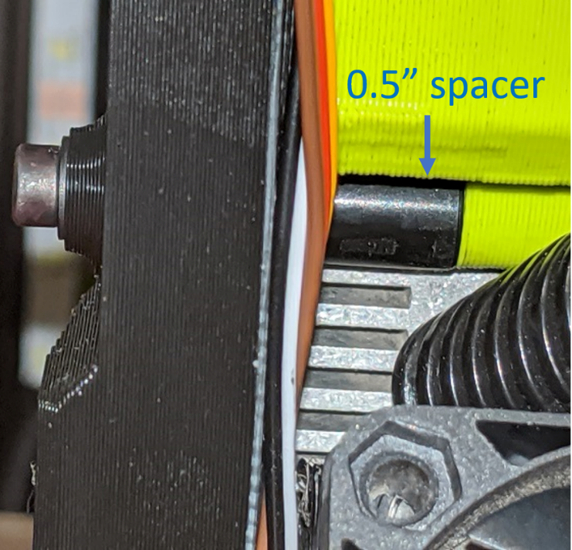

CAD model of the mount. 0.5” spacer between the mount and existing housing.

The mount adds some extra thickness, thus new fasteners needed to be used. The top fastener is M3x20mm and the bottom is M3x40mm. The mount is fastened to the mount using #4-40x5/16” fasteners threaded into heat inserts on the bottom. The result is a ridged mount that conveniently locates the BLTouch on the Lulzbot Dual v3 toolhead.

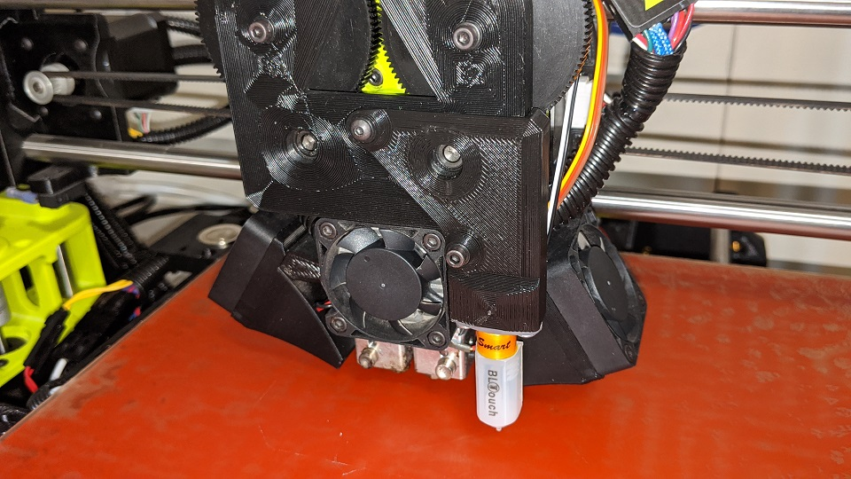

# Firmware

The firmware changes that are needed to enable the BLTouch vary based on what firmware you are using (duh). This section will cover Marlin and Klipper. Please note that I have not done this with Marlin, however, since it is so popular, I have compiled everything needed to implement it (hopefully).

**With the Marlin firmware**, the idea is that the probe and control signals are monitored and driven by existing device “types”, for lack of a better term. The probe pin is monitored by the Z-Min end stop. This means that the BLTouch will replace that endstop. It is possible to use another pin and write some custom firmware to use it if repurposing the Z-Min connection is not desired and using the GPIO method.

So, with Marlin, the control pin is driven by a “SERVO” and the probe pin is monitored by an ENDSTOP (specifically, Z-Min). Servo pins are defined for different boards based on a header file located in the source codes “pins” directory:  
<https://github.com/MarlinFirmware/Marlin/tree/2.0.x/Marlin/src/pins>

The Archim2 uses the following file:  
<https://github.com/MarlinFirmware/Marlin/blob/2.0.x/Marlin/src/pins/sam/pins_ARCHIM2.h>

Find your board to find the SERVO pins.

**With the Klipper firmware**, you can easily setup a BLTouch device and configure it by adding a [[BLTouch] config section](https://github.com/KevinOConnor/klipper/blob/master/config/example-extras.cfg) and defining the proper parameters in the config file. The device can then be controlled using the Extended Gcode commands found [here](https://github.com/KevinOConnor/klipper/blob/master/docs/BLTouch.md). Any pin on the GPIO header can be used for probe and control, however, the pins selected in this guide allow for compatibility with both Marlin and Klipper.

Details on each firmware are available in the below sections.

## Marlin

### Using Z-Min

Marlin already has built in support for the BLTouch; it just needs to be enabled. The developer of the BLTouch has included documentation on how to do this.

From v3.1 User Manual, edit the Configuration.h file to use the BLTouch connected to the Z-Min connector:

//===================== Endstop Settings ===========================  
#define USE_ZMIN_PLUG // a Z probe  
#define ENDSTOPPULLUPS  
#define ENDSTOP_INTERRUPTS_FEATURE  
//===================== Z Probe Options =============================  
#define Z_MIN_PROBE_USES_Z_MIN_ENDSTOP_PIN  
#define BLTOUCH  
#if ENABLED(BLTOUCH)  
//#define BLTOUCH_DELAY 500 // *option  
//#define BLTOUCH_FORCE_5V_MODE  
#endif  
#define PROBING_HEATERS_OFF // *option  
#define PROBING_FANS_OFF // *option  
#define X_PROBE_OFFSET_FROM_EXTRUDER 0 //Depend on your BLTouch installation value  
#define Y_PROBE_OFFSET_FROM_EXTRUDER -22 //Depend on your BLTouch installation value  
#define Z_PROBE_OFFSET_FROM_EXTRUDER -2.35 //Depend on your BLTouch installation value  
//It must be greater than or equal to the higher of the X_PROBE_OFFSET_FROM_EXTRUDER and Y_PROBE_OFFSET_FROM_EXTRUDER.  
#define MIN_PROBE_EDGE 22  
#define Z_PROBE_SPEED_FAST HOMING_FEEDRATE_Z / 5  
#define Z_CLEARANCE_DEPLOY_PROBE 15 // set up at least 10  
#define Z_CLEARANCE_BETWEEN_PROBES 5 // set up at least 5 //====================== Bed Leveling ==============================  
#define AUTO_BED_LEVELING_BILINEAR // *option

The control pin needs to be connected to a servo pin so that it can be controlled with the M280 command. The servo pin can be found in pins_<YOUR CONTROLLER BOARD>.h. For example:  
<https://github.com/MarlinFirmware/Marlin/blob/2.0.x/Marlin/src/pins/sam/pins_ARCHIM2.h> shows two servo pins (SERVO0_PIN and SERVO1_PIN) on 20 (J20-20, PB12) and 21 (J20-19, PB13) respectively.

Then:  
M280 P0 S90 ;gcode to control BLTouch using SERVO0_PIN  
M280 P1 S90 ;gcode to control BLTouch using SERVO1_PIN

For other boards, simply look up the servo pins in the appropriate ‘pins_<>.h’ header file.

## Klipper

With Klipper, everything is defined in the configuration file. I removed the “endstop_pin” definition with the pin from the Z-Min switch and added the virtual end stop created by enabling the [bltouch] section.

[stepper_z]

step_pin = PC17

dir_pin = PC16

enable_pin = !PC19

step_distance = 0.000625

#endstop_pin = !PA7 #<- manual Z-Min button

endstop_pin = probe:z_virtual_endstop

position_min: -2.0

position_max: 270

homing_speed: 10

second_homing_speed: 1

Here is my config entry for the Archim2 based on the pin decisions outlined above. The addition of this section creates the “probe:z_virtual_endstop” object. The config section below illustrates both GPIO and Z-Min definitions. Uncomment out the one in use and comment out the one not in use.  
Your pin definitions may vary:

[bltouch]

#Using the GPIO pin for Probe

sensor_pin: ^PB1

#Using the Z-Min pin for Probe

sensor_pin: !PA7

control_pin: PB12

pin_move_time: 0.675

pin_up_reports_not_triggered: True

pin_up_touch_mode_reports_triggered: False

#Offsets using custom Dual v3 BLTouch face mount

x_offset: 34

y_offset: -23

z_offset: 2.925

speed: 10

samples: 2

sample_retract_dist: 5

samples_result: average

samples_tolerance: 0.1

samples_tolerance_retries: 2

**Disclaimer:** You do this work at your own risk. Your warranty will likely be voided by doing this. It is up to the implementer if the advantages of doing this work outweigh the risks. I have not run this configuration with Marlin firmware yet, so there may be other needed modifications if using that codebase, although I cannot think of any. I use Klipper firmware to run my printer currently and it allows for custom pin definition in a configuration file. This was done for the bed leveling probe using the GPIO header.

# APPENDIX

## Digikey Parts BOM

Below is the list of parts that are needed to complete the electrical work outlined in this document. This lists the parts for both types of install methods.

|  |  |  |  |  |  |
| --- | --- | --- | --- | --- | --- |
| **Index** | **Quantity** | **Part Number** | **Manufacturer Part Number** | **Description** | **Use** |
| 1 | 1 | WM2902-ND | 0050579404 | CONN HOUSING 4POS .100 W/LATCH | EXT Power connector for 5V and GND |
| 2 | 50 | WM2510CT-ND | 0016020086 | CONN SOCKET 22-24AWG CRIMP TIN | Female crimps for EXT Power |
| 3 | 50 | WM2517CT-ND | 0016020107 | CONN PIN 22-24AWG CRIMP TIN | Male crimps for limit switch |
| 4 | 6 | WM2901-ND | 0050579403 | CONN HOUSING 3POS .100 W/LATCH | Female connector for limit switch |
| 5 | 6 | WM2534-ND | 0701070002 | CONN HOUSING MALE 3POS .100 | Male connector for limit switch extensions |
| 6 | 1 | 23-0022552241-ND | 0022552241 | CONN HOUSING 24POS .100 DUAL | GPIO connector housing block |
| 7 | 50 | WM14366CT-ND | 0700580086 | CONN SOCKET 22-24AWG CRIMP TIN | Crimps for GPIO housing block |

## Wiring Diagrams

### Using GPIO

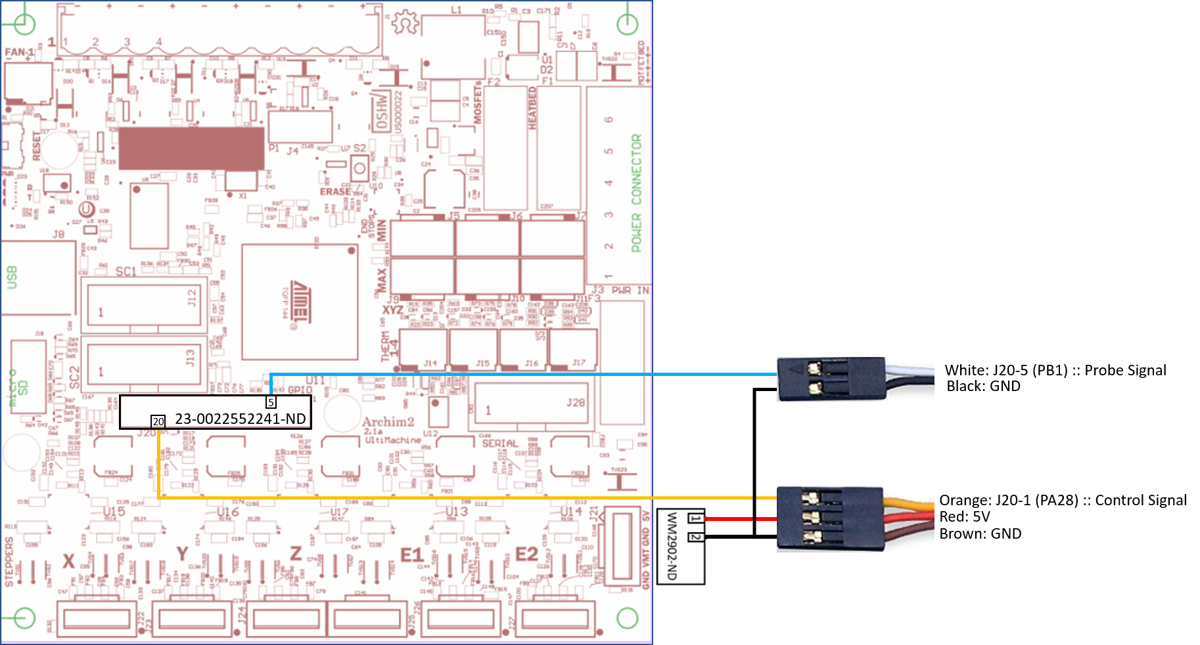

### Using Z-Min

